Left Recursion and Left Factoring

# 

# Submitted to:

* Dr. Talha Waheed

# Submitted by:

* Komal Shehzadi (2016-CS-178)

# Department of Computer Science and Engineering

# UET Lahore





**IN MANUAL FORMAT:**

For some cases I have not wrote the complete productions in hand written assignment because of low space. Compete productions are available in word table at the end of the document.

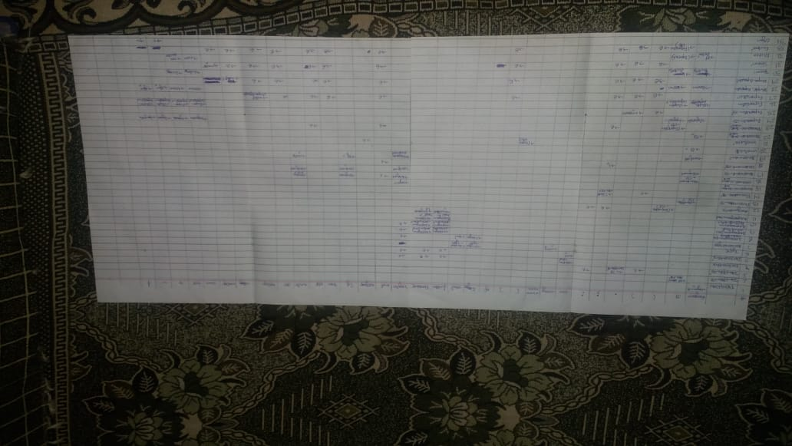

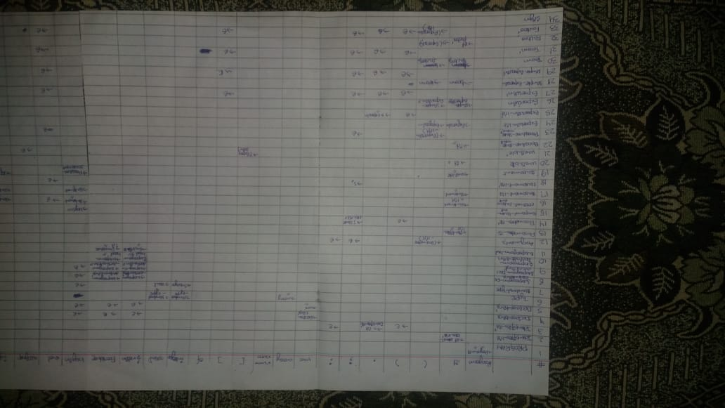

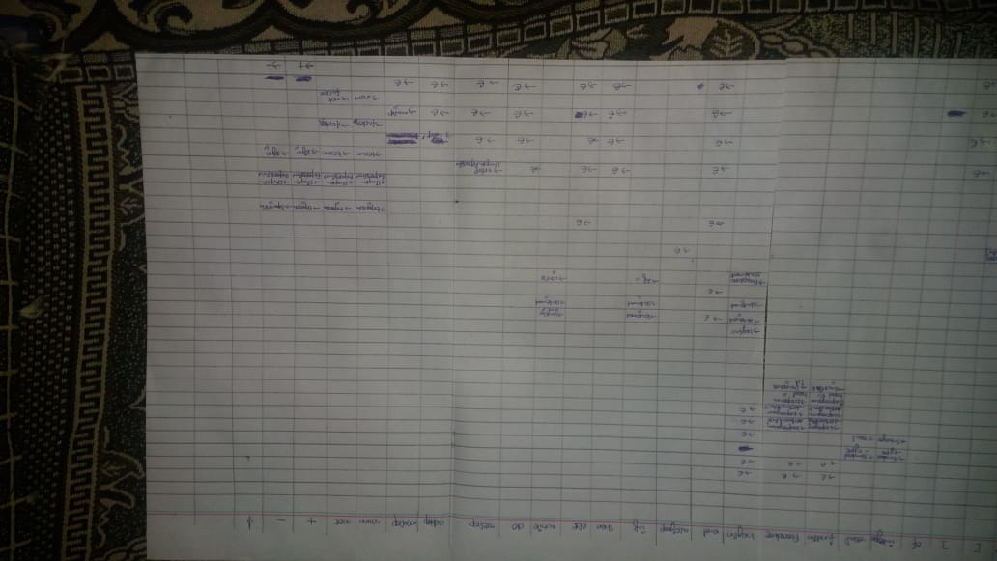

**IN WORD TABLE**

|  |  |  |  |  |  |  |  |  |  |  |  |  |  |  |  |  |  |  |  |  |  |  |  |  |  |  |  |  |  |  |  |  |  |
| --- | --- | --- | --- | --- | --- | --- | --- | --- | --- | --- | --- | --- | --- | --- | --- | --- | --- | --- | --- | --- | --- | --- | --- | --- | --- | --- | --- | --- | --- | --- | --- | --- | --- |
|  | **program** | **id** | **(** | **)** | **,** | **;** | **:** | **var** | **array** | **num . . num** | **[** | **]** | **of** | **integer** | **real** | **function** | **procedure** | **begin** | **end** | **assignop** | **if** | **then** | **else** | **while** | **do** | **relop** | **addop** | **mulop** | **num** | **not** | **+** | **-** | **$** |
| PROGRAM | PROGRAM -> **program id** ( identifier_list ) ; declarations subprogram_declarations compound_statement |  |  |  |  |  |  |  |  |  |  |  |  |  |  |  |  |  |  |  |  |  |  |  |  |  |  |  |  |  |  |  |  |
| identifier_list |  | identifier_list -> **id** identifier_list’ |  |  |  |  |  |  |  |  |  |  |  |  |  |  |  |  |  |  |  |  |  |  |  |  |  |  |  |  |  |  |  |
| identifier_list’ |  |  |  | identifier_list’ ->   | identifier_list’ -> , **id** identifier_list’ |  | identifier_list’ ->   |  |  |  |  |  |  |  |  |  |  |  |  |  |  |  |  |  |  |  |  |  |  |  |  |  |  |
| declarations |  |  |  |  |  |  |  | declarations -> declarations’ |  |  |  |  |  |  |  | declarations ->   | declarations ->   | declarations ->   |  |  |  |  |  |  |  |  |  |  |  |  |  |  |  |
| declarations’ |  |  |  |  |  |  |  | declarations’ -> **var** identifier_list : type ; declarations’ |  |  |  |  |  |  |  | declarations’ ->   | declarations’ ->   | declarations’ ->   |  |  |  |  |  |  |  |  |  |  |  |  |  |  |  |
| type |  |  |  |  |  |  |  |  | type ->  **array [ num . . num ] of** standard_type |  |  |  |  | type -> standard_type | type -> standard_type |  |  |  |  |  |  |  |  |  |  |  |  |  |  |  |  |  |  |
| standard_type |  |  |  |  |  |  |  |  |  |  |  |  |  | standard_type -> **integer** | standard_type -> **real** |  |  |  |  |  |  |  |  |  |  |  |  |  |  |  |  |  |  |
| subprogram_declarations |  |  |  |  |  |  |  |  |  |  |  |  |  |  |  | subprogram_declarations -> subprogram_declarations’ | subprogram_declarations -> subprogram_declarations’ | subprogram_declarations ->   |  |  |  |  |  |  |  |  |  |  |  |  |  |  |  |
| subprogram_declarations’ |  |  |  |  |  |  |  |  |  |  |  |  |  |  |  | subprogram_declarations’ -> subprogram_declaration ; subprogram_declarations’ | subprogram_declarations’ -> subprogram_declaration ; subprogram_declarations’ | subprogram_declarations’ ->   |  |  |  |  |  |  |  |  |  |  |  |  |  |  |  |
| subprogram_declaration |  |  |  |  |  |  |  |  |  |  |  |  |  |  |  | subprogram_declaration -> subprogram_head declarations compound_statement | subprogram_declaration -> subprogram_head declarations compound_statement |  |  |  |  |  |  |  |  |  |  |  |  |  |  |  |  |
| subprogram_head |  |  |  |  |  |  |  |  |  |  |  |  |  |  |  | subprogram_head -> **function id** arguments : standard_type | subprogram_head ->  **procedure id** arguments ; |  |  |  |  |  |  |  |  |  |  |  |  |  |  |  |  |
| arguments |  |  | arguments -> ( parameter_list ) |  |  | arguments ->   | arguments ->   |  |  |  |  |  |  |  |  |  |  |  |  |  |  |  |  |  |  |  |  |  |  |  |  |  |  |
| parameter_list |  | parameter_list -> identifier_list : type parameter_list’ |  |  |  |  |  |  |  |  |  |  |  |  |  |  |  |  |  |  |  |  |  |  |  |  |  |  |  |  |  |  |  |
| parameter_list’ |  |  |  | parameter_list’ ->   |  | parameter_list’ -> ; identifier_list : type parameter_list’ |  |  |  |  |  |  |  |  |  |  |  |  |  |  |  |  |  |  |  |  |  |  |  |  |  |  |  |
| compound_statement |  |  |  |  |  |  |  |  |  |  |  |  |  |  |  |  |  | compound_statement -> **begin** optional_statements **end** |  |  |  |  |  |  |  |  |  |  |  |  |  |  |  |
| optional_statements |  | optional_statements -> statement_list |  |  |  |  |  |  |  |  |  |  |  |  |  |  |  | optional_statements -> statement_list | optional_statements ->   |  | optional_statements -> statement_list |  |  | optional_statements -> statement_list |  |  |  |  |  |  |  |  |  |
| statement_list |  | statement_list -> statement statement_list’ |  |  |  |  |  |  |  |  |  |  |  |  |  |  |  | statement_list -> statement statement_list’ |  |  | statement_list -> statement statement_list’ |  |  | statement_list -> statement statement_list’ |  |  |  |  |  |  |  |  |  |
| statement_list’ |  |  |  |  |  | statement_list’ -> ; statement statement_list’ |  |  |  |  |  |  |  |  |  |  |  |  | statement_list’ ->   |  |  |  |  |  |  |  |  |  |  |  |  |  |  |
| statement |  | statement -> variable **assignop** expression |  |  |  |  |  |  |  |  |  |  |  |  |  |  |  | statement -> procedure_statement |  |  | statement -> **if** expression **then** statement **else** |  |  | statement -> **while** expression **do** statement |  |  |  |  |  |  |  |  |  |
| variable |  | variable -> **id** variable’ |  |  |  |  |  |  |  |  |  |  |  |  |  |  |  |  |  |  |  |  |  |  |  |  |  |  |  |  |  |  |  |
| variable’ |  |  |  |  |  |  |  |  |  |  | variable’ -> [ expression ] |  |  |  |  |  |  |  |  | variable’ ->   |  |  |  |  |  |  |  |  |  |  |  |  |  |
| procedure_statement |  | procedure_statement -> **id** procedure_statement’ |  |  |  |  |  |  |  |  |  |  |  |  |  |  |  |  |  |  |  |  |  |  |  |  |  |  |  |  |  |  |  |
| procedure_statement’ |  |  | procedure_statement’ ->  expression_list  |  |  | procedure_statement’ ->  |  |  |  |  |  |  |  |  |  |  |  |  | procedure_statement’ ->  |  |  |  | procedure_statement’ ->  |  |  |  |  |  |  |  |  |  |  |
| expression_list |  | expression_list -> expression expression_list’ | expression_list -> expression expression_list’ |  |  |  |  |  |  |  |  |  |  |  |  |  |  |  |  |  |  |  |  |  |  |  |  |  | expression_list -> expression expression_list’ | expression_list -> expression expression_list’ | expression_list -> expression expression_list’ | expression_list -> expression expression_list’ |  |
| expression_list’ |  |  |  | expression_list’ ->   | expression_list’ -> , expression expression_list’ |  |  |  |  |  |  |  |  |  |  |  |  |  |  |  |  |  |  |  |  |  |  |  |  |  |  |  |  |
| expression |  | expression -> simple_expression expression’ | expression -> simple_expression expression’ |  |  |  |  |  |  |  |  |  |  |  |  |  |  |  |  |  |  |  |  |  |  |  |  |  | expression -> simple_expression expression’ | expression -> simple_expression expression’ | expression -> simple_expression expression’ | expression -> simple_expression expression’ |  |
| expression’ |  |  |  | expression’ ->   | expression’ ->   | expression’ ->   |  |  |  |  |  | expression’ ->   |  |  |  |  |  |  | expression’ ->   |  |  | expression’ ->   | expression’ ->   |  | expression’ ->   | expression’ -> **relop** simple_expression |  |  |  |  |  |  |  |
| simple_expression |  | simple_expression -> term simple_expression’ | simple_expression -> term simple_expression’ |  |  |  |  |  |  |  |  |  |  |  |  |  |  |  |  |  |  |  |  |  |  |  |  |  | simple_expression -> term simple_expression’ | simple_expression -> term simple_expression’ | simple_expression -> sign term simple_expression’ | simple_expression -> sign term simple_expression’ |  |
| simple_expression’ |  |  |  | simple_expression’ ->   | simple_expression’ ->   | simple_expression’ ->   |  |  |  |  |  | simple_expression’ ->   |  |  |  |  |  |  | simple_expression’ ->   |  |  | simple_expression’ ->   | simple_expression’ ->   |  | simple_expression’ ->   | simple_expression’ ->   | simple_expression’ -> **addop** term simple_expression’ |  |  |  |  |  |  |
| term |  | term -> factor term’ | term -> factor term’ |  |  |  |  |  |  |  |  |  |  |  |  |  |  |  |  |  |  |  |  |  |  |  |  |  | term -> factor term’ | term -> factor term’ |  |  |  |
| term’ |  |  |  | term’ ->  | term’ ->  | term’ ->  |  |  |  |  |  | term’ ->  |  |  |  |  |  |  | term’ ->  |  |  | term’ ->  | term’ ->  |  | term’ ->  | term’ ->  | term’ ->  | term’ -> **mulop** factor term’ |  |  |  |  |  |
| factor |  | factor -> **id** factor’ | factor -> ( expression ) |  |  |  |  |  |  |  |  | ’ |  |  |  |  |  |  |  |  |  |  |  |  |  |  |  |  | factor -> **num** | factor -> **not** |  |  |  |
| factor’ |  |  | factor’ -> ( expression_list ) | factor’ ->   | factor’ ->   | factor’ ->   |  |  |  |  |  | factor’ ->   |  |  |  |  |  |  | factor’ ->   |  |  | factor’ ->   | factor’ ->   |  | factor’ ->   | factor’ ->   | factor’ ->   | factor’ ->   |  |  |  |  |  |
| sign |  |  |  |  |  |  |  |  |  |  |  |  |  |  |  |  |  |  |  |  |  |  |  |  |  |  |  |  |  |  | sign -> **+** | sign -> **-** |  |